**EXPERIMENT-6**

**DATE;29-09-2025**

**AIM;** To demonstrate virtualization by installing type-2 hypervisor in your device, create and configure VM image with a host operating system (either window/Linux).

**PROCEDURE:**

**STEP 1:** Download VMware workstation and installed as type 2 hypervisor.

**STEP2:** Download ubuntu or tiny OS as iso image file.

**STEP 3:** In VMware workstation->create new VM.

**STEP 4:** Do the basic configuration settings.

**STEP 5:** Created tiny OS virtual machine.

**STEP 6:** Launch the VM.

**IMPLEMENTATION:**

**STEP 1: DOWNLOAD VMWARE WORKSTATION AND INSTALLED AS TYPE HYPERVISOR**

**STEP2: DOWLOAD UBUNTU OR TINY OS AS ISO IMAGE FILE**

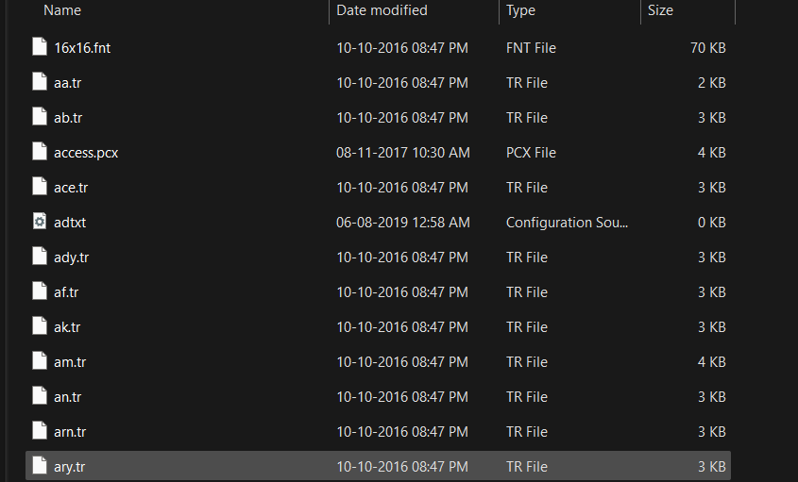

**STEP 3: IN VMWARE WORKSTATION->CREATE NEW VM**

**STEP 4: DO THE BASIC CONFIGURATION SETTINGS.**

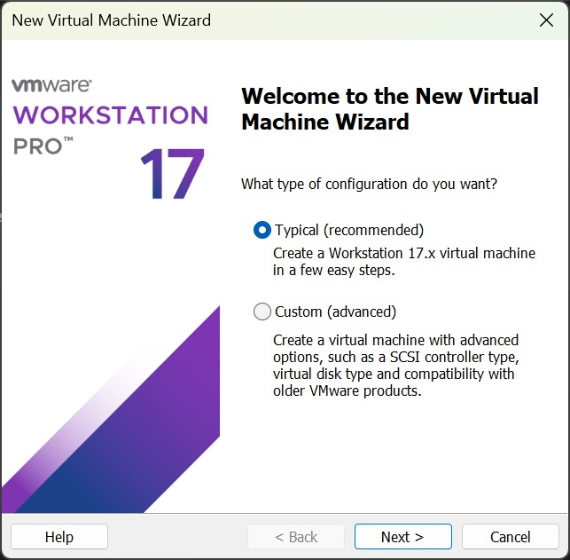

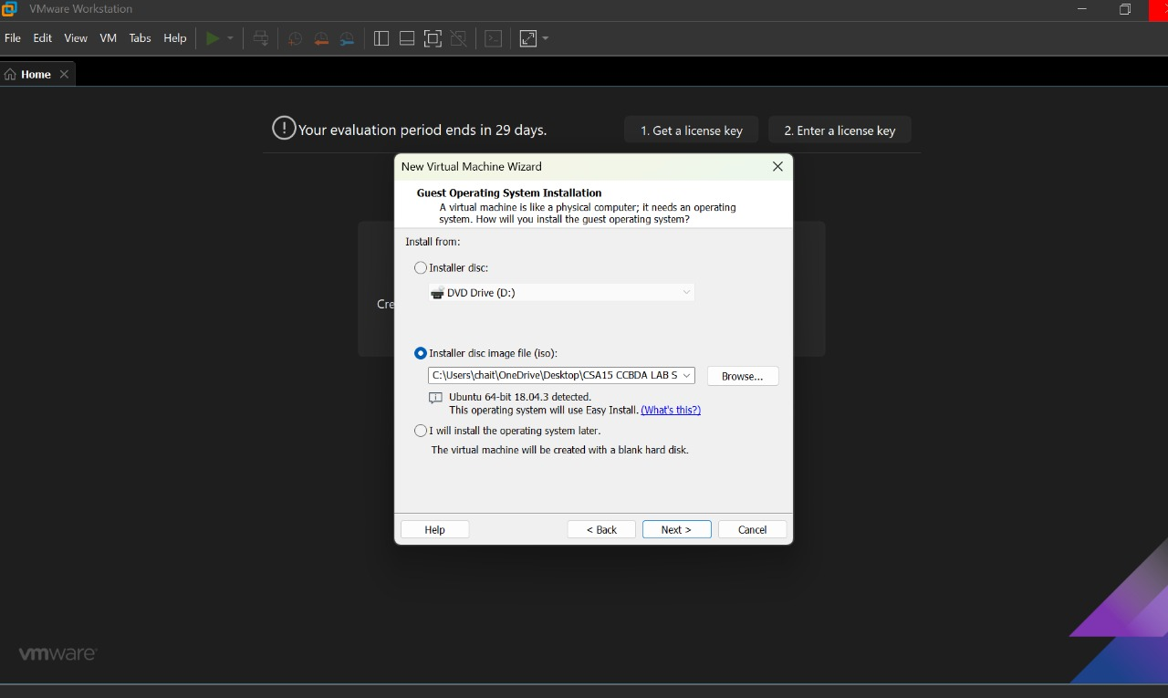

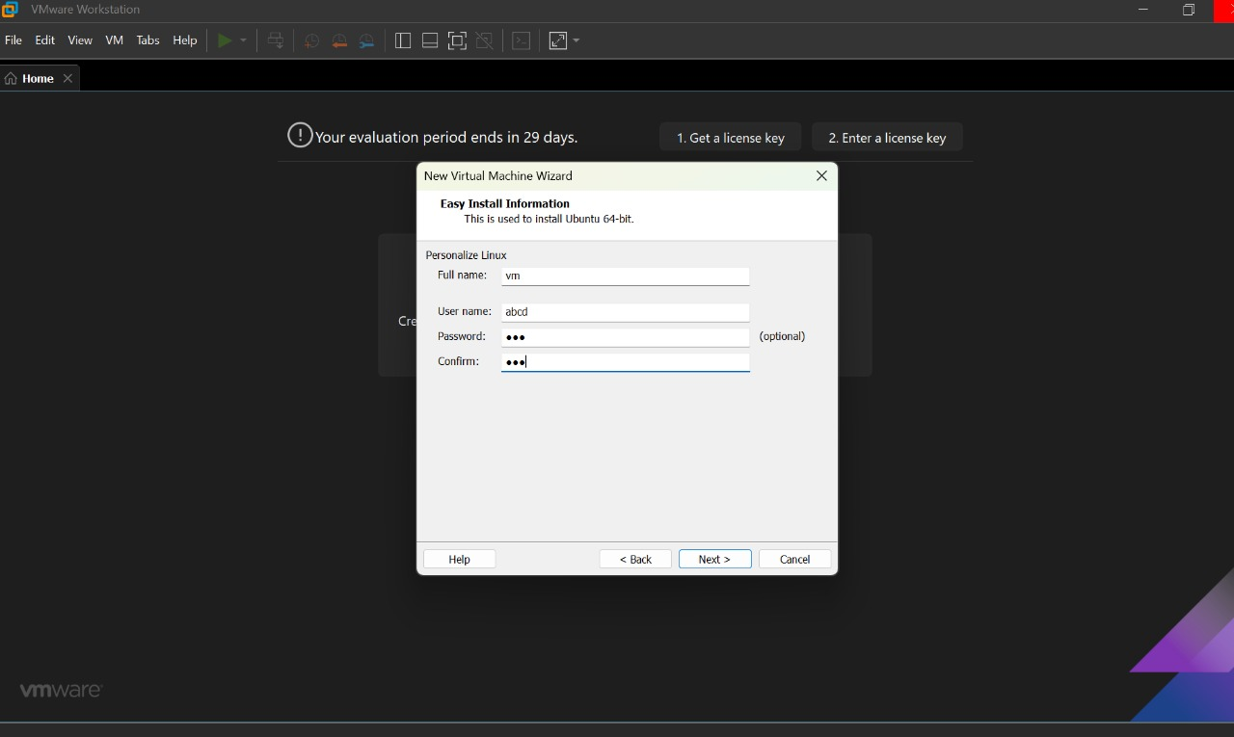

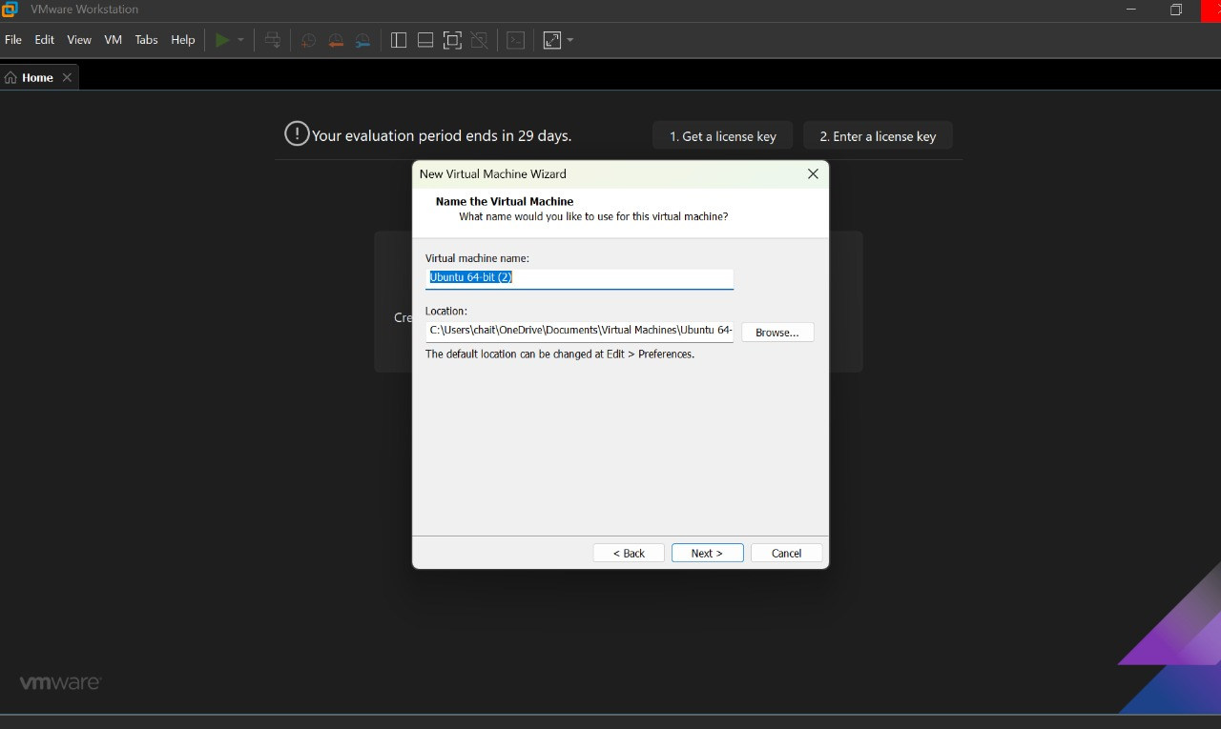

**STEP 5: CREATED TINYOS VIRTUAL MACHINE**

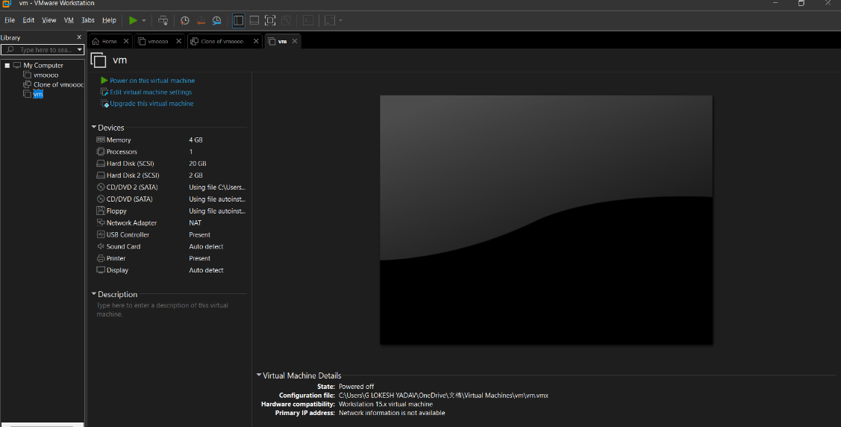

**STEP 6: LAUNCH THE VM**

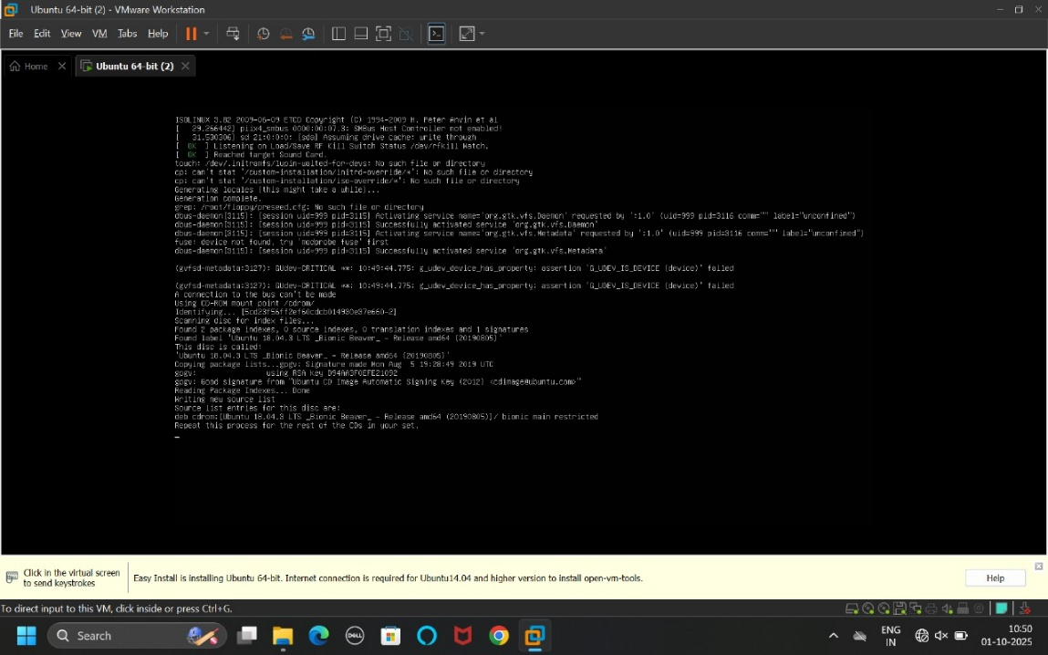

**RESULTS;** successfully demonstrated virtualization by installing type-2 hypervisor in your device, create and configure VM image with a host operating system